Log

It is highly probable that at some point on your path to develop your application something won't happen as expected.

The debugger in Android Studio is rather standard and if you are used to Eclipse for instance you will be able to use it easily to trace the execution and to sort out the problems.

When developing desktop applications you can also rely on exception messages and stack traces printed to the error output stream to figure what is going wrong. The equivalent for Android is the *Logging System*:

* Using [**the Log class**](http://developer.android.com/reference/android/util/Log.html) you can record debug messages during the execution (this is kind of the equivalent to a System.err.println("the value of d is "+d) ). Messages can categorized using a tag and a priority level (debug, warning, fatal, etc.).
* The Android Studio **LogCat window** displays both the Log messages you wrote in your Java code, and the debug messages generated by the system. This LogCat provides additional functionalities, such as filtering to select the messages to be displayed.

Open one of your previous project and add the following code to one of your method (don't forget to add the android.util.Log import clause):

Log.i("TAG_I_made_up", "I'm here!");

The *i* method is used to log informational messages. The "TAG_I_made_up" String tags the message; the tag can be used to filter the message in the LogCat. The second String parameter is the debugging message itself.

If the LogCat view is not already displayed in your Android Studio, click the View menu, Tool Windows / Android Monitor and in the Android Monitor select the logcat tab.

Next execute your application on an emulator.

When the execution reaches the point where you've inserted the Log.i instruction, the logcat should list something similar to:

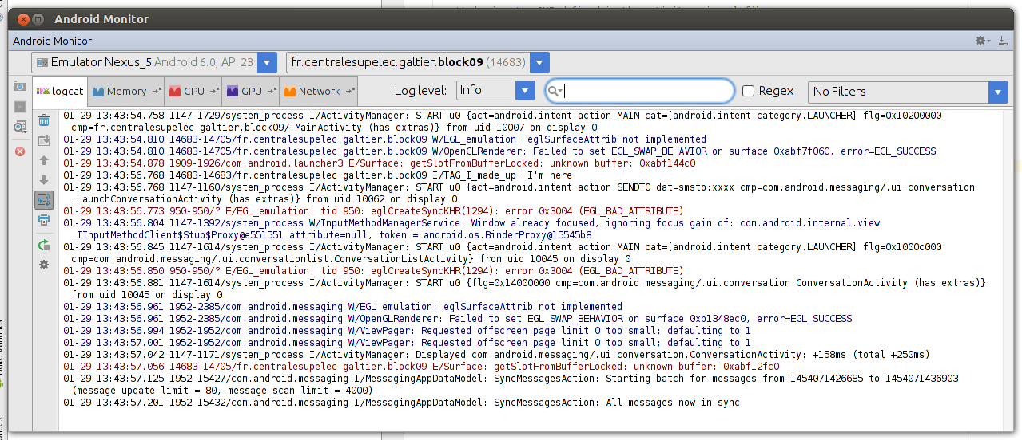

Edit a filter using the drop-down menu in the upper right corner:

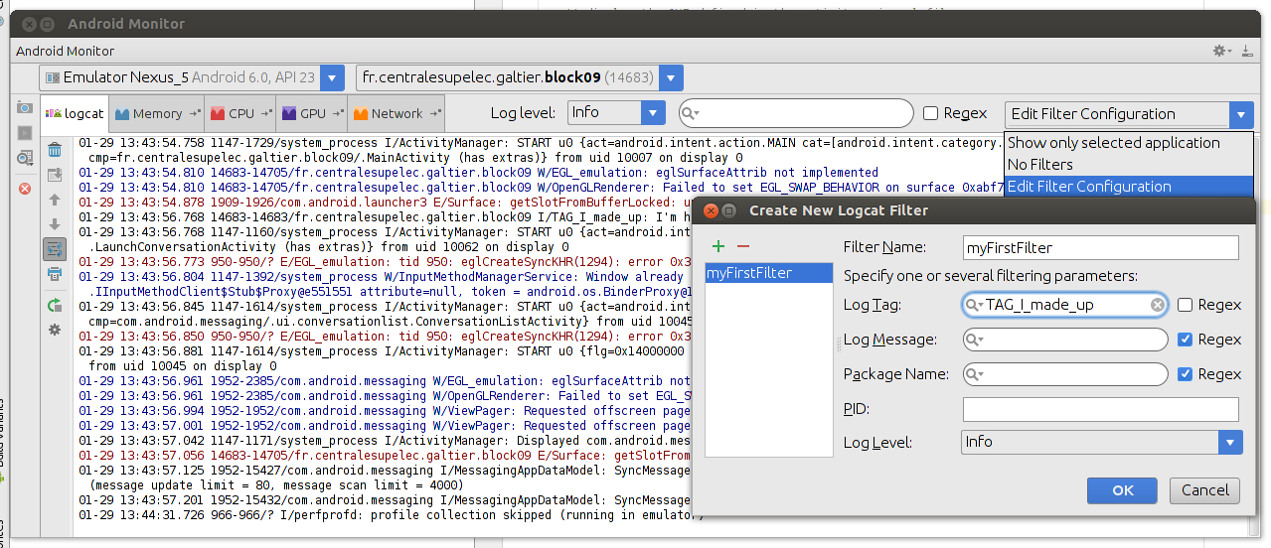

Apply the filter:

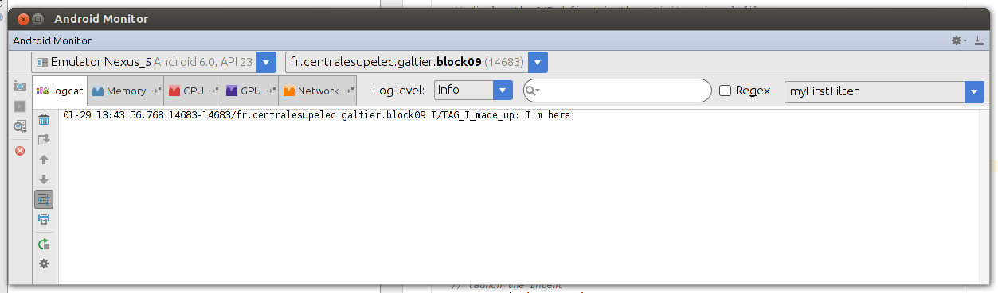

Read [more about this debugging tool in the Android documentation](http://developer.android.com/tools/debugging/debugging-log.html).